Search...

How to Read Manual Pages in Linux | man Command
Last Updated : 10 Jun, 2024

The "man" command, short for manual, is a powerful tool in the Linux operating system that allows users to access detailed information about various commands, utilities, and system calls. The "man" command provides comprehensive documentation, helping users understand how to use and configure different elements of the Linux environment. This article will explore the "man" command in detail, covering its syntax, and options, and providing practical examples.

Table of Content
What is man in Linux Command? Man Command Options
Accessing Manual Pages
Navigating Manual Pages Sections in Manual Pages
Types of sections in Man command Manuals
Examples of Man Command section ty pes with Detailing How to Search Manual Pages in Linux?
Alternative ways to read man pages

What is man in Linux Command?
The man command in Linux is used to display the manual pages for other commands and utilities. It provides detailed documentation about the usage, options, and functionality of commands, making it an essential tool for both beginners and experienced users. Each manual page includes sections such as NAME, SYNOPSIS, DESCRIPTION, OPTIONS, and EXAMPLES, which help users understand and effectively use the command.

Description

The man command is essentially the Linux manual reader. When you type man followed by a command name, it retrieves and displays the manual page for that command, offering comprehensive details on how to use it, including all available options and flags. This command is crucial for learning about the tools and commands available in the Linux operating system.

Syntax of the "man" Command

The basic syntax of the "man" command is as follows:

man [option] [command]

Here,

"option" refers to additional flags that modify the behavior of the "man" command,
"command" is the Linux command or utility for which you want to access the manual.
Related searches

Exp
Man Command in Linux
Man Command in Linux in Hindi

Man Command Options
The "man" command itself has options that enhance its functionality:

Option | Description
man [command] | Display the manual page for the specified command.
-f, --whatis | Display a concise one-line description of the command.
-k, --apropos | Search for commands related to a given keyword.
-a, --all | Display all matching manual pages for the specified command.
Spacebar | Move forward one page in the manual.
Enter | Move forward one line in the manual.
B | Move backward one page in the manual.
Q | Quit the manual viewer.

Accessing Manual Pages
To access the manual page for a specific command, simply type:

man [command]

For example: To view the manual for the "ls" command execute the following command:

man ls

This will display detailed information about the "ls" command, including its usage, options, and examples.

Navigating Manual Pages
Once you've accessed a manual page, you can navigate through it using various commands. The common navigation keys include:
Spacebar: Move forward one page. Enter: Move forward one line.
B: Move backward one page. Q: Quit the manual viewer.

Sections in Manual Pages
Manual pages are organized into different sections, each serving a specific purpose. The primary sections include:
NAME: Provides the name and a brief description of the command.
SYNOPSIS: Describes the syntax of the command.
Shell Scripting | Kali Linux | Ubuntu | Red Hat | CentOS | Docker in Linux | Kubern |  | Sign In

DESCRIPTION: Offers a detailed explanation of the command's functionality.
OPTIONS: Lists the available command-line options and their descriptions.
EXAMPLES: Provides practical examples demonstrating command usage.
SEE ALSO: Suggests related commands or resources.

Types of sections in Man command Manuals
The man command manuals are divided into several sections, each providing specific types of information about the commands and features of the Linux operating system. Understanding these sections helps users navigate the extensive documentation efficiently. Every manual is divided into the following sections:
- Executable programs or shell commands: Commands that can be executed in the shell, like ls, cd, or grep.

- System calls: Functions provided by the kernel, such as open, read, and write.
- Library calls: Functions within program libraries, like those in the C
standard library, such as printf and malloc.
- Games: Documentation for games available on the system.
- Special files: Usually found in /dev, these include device files like
/dev/null and /dev/sda.
- File formats and conventions: Details on file formats and conventions, e.g., /etc/passwd.
- Miscellaneous: Including macro packages and conventions, e.g.,
groff(7).
- System administration commands: Commands typically used by the root user for system administration tasks, like iptables or mount.
- Kernel routines: Non-standard kernel routines used within the system.

Examples of Man Command section types with Detailing
The following are the examples of man command section types with
detailing:

Section-num in man Command in Linux

In the man command manuals, sections are used to categorize different types of information. You can specify a section number to display only the relevant section of a manual.

Syntax

man [SECTION-NUM] [COMMAND NAME]

Example

man 2 intro

Output
This command displays the manual entry for the intro in section 2, which pertains to system calls. Specifying a section number ensures you

get the precise information you need from the extensive Linux manual pages.
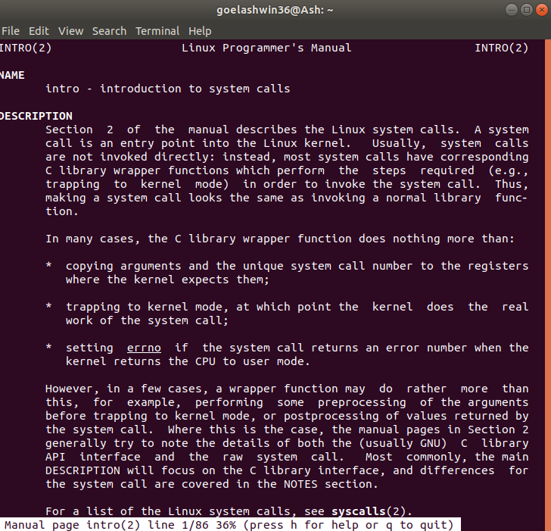
In this example, the manual pages of command 'intro' are returned which lies in the section 2.

-f option in man Command in Linux

One may not be able to remember the sections in which a command is present. So this option gives the section in which the given command is present.

Syntax

man -f [COMMAND NAME]

Example

man -f ls

Output
This command lists the sections where the ls command appears, indicating that ls is documented in section 1.

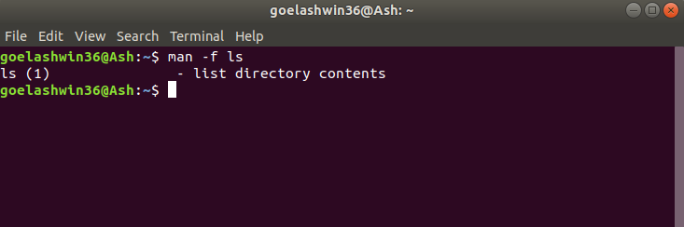

-a option in man Command in Linux

This option helps us to display all the available intro manual pages in succession.

Syntax

man -a [COMMAND NAME]

Example

man -a intro

Output
This command will show all intro manual pages one after the other, allowing you to cycle through them to find the specific information you need. This is useful for viewing multiple sections that a command might be documented in.
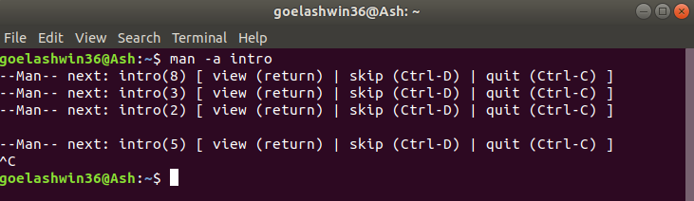
The following screenshot illustrate on the manual pages of intro of section 2:

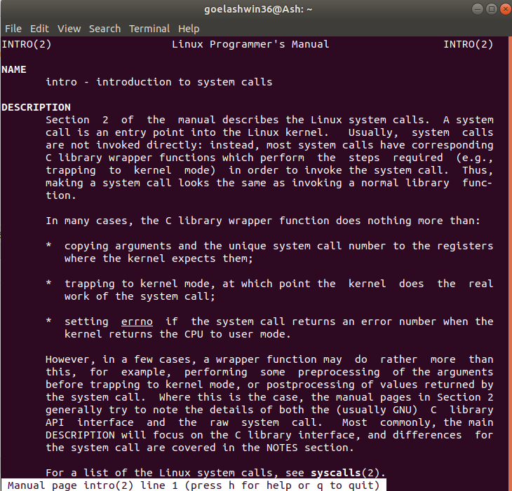
In this example you can move through the manual pages(sections) i.e either reading(by pressing Enter) or skipping(by pressing ctrl+D) or exiting(by pressing ctrl+C).

-k option in man Command in Linux

The -k option in the man command allows you to search for a command as a regular expression across all manual pages, returning a list of matching entries along with their section numbers.

Syntax

man -k [COMMAND NAME]

Example

man -k cd

Output
This command searches for the term "cd" in all manual pages and displays the relevant entries along with the sections where they are found. This is useful for finding related commands and topics within the manual pages.

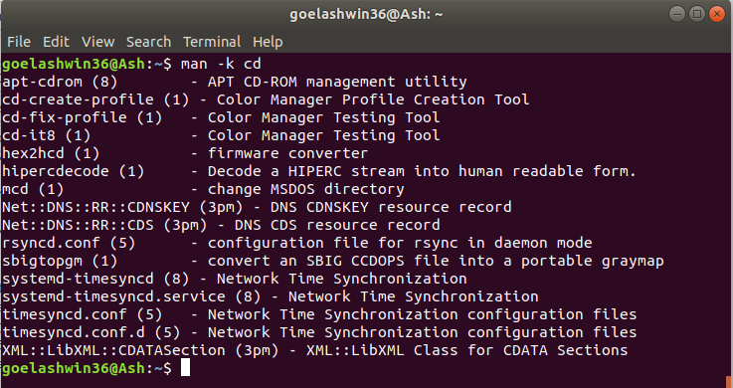
The command 'cd' is searched in all the manual pages by considering it as a regular expression.

-w option in man Command in Linux

The -w option in the man command returns the location of the manual page for a given command. This is useful for finding where the manual pages are stored on the system.

Syntax

man -w [COMMAND NAME]

Example

man -w ls

Output
In this example, the command man -w ls outputs the path to the manual page for the ls command, indicating where the documentation file is located on the system.
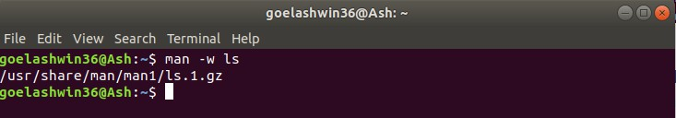
The location of command 'ls' is returned.

-I option in man Command in Linux

The -I option in the man command makes the search case-sensitive, ensuring that the command name is considered with exact case.

Syntax

man -I [COMMAND NAME]

Example
The execution of following command helps in finding the manuals of printf command with case sensitiveness.

man -I printf

Output
This command searches for the manual pages of the printf command, treating the command name with case sensitivity. This is useful when differentiating between commands or sections that have similar names but different cases.
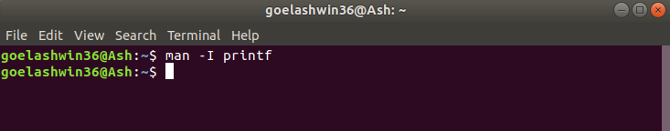
The following screenshot illustrates the manual of printf command with case -sensitive:

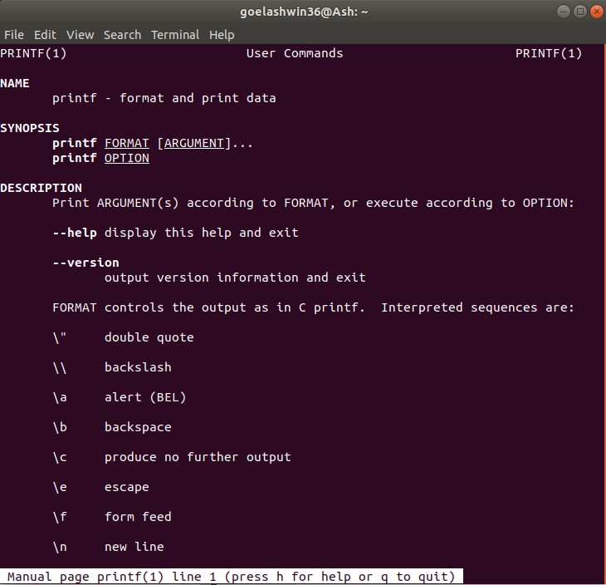
The following looks for the manual pages for Printf command with case sensitive:
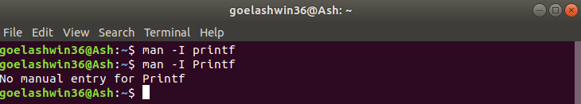
The command 'printf' is taken as case-sensitive i.e 'printf' returns the manual pages but 'Printf' gives error.

How to Search Manual Pages in Linux?
There are three main ways:
- Using the `man` command: This is the classic approach. Type `man` followed by the command name to find its manual page. For example, `man mkdir` will show you the manual page for the `mkdir` command.
- Using the `-k` option: Want to search for keywords across all manual pages? Use man -k followed by your keyword(s). For instance,
`man -k permissions` will find pages mentioning "permissions".
- Using the `apropos` command: Similar to `man -k`, but `apropos` also searches descriptions, not just names. Try `apropos networking` to find pages related to networking.

Alternative ways to read man pages
The following are the alternative ways to read man pages:

man2html: Converts man pages to HTML format, which can be easier to read on a graphical user interface (GUI).
tldr: Provides shorter, simplified versions of man pages.
whatis: Gives a very brief one-line summary of a command.
apropos: Searches the man pages for keywords and provides a list of commands and their brief descriptions.
info: Displays more detailed and hyperlinked documentation about
commands and programs, often including more background information than man pages.

Conclusion
In this article we discussed the "man" command in Linux which is an essential tool for accessing detailed documentation on commands, utilities, and system calls. It provides a comprehensive guide with organized sections, including syntax, options, and examples. With options like -f, -k, and -a, users can quickly retrieve concise descriptions, search related commands, and access all matching manual pages.
Navigating through manual pages is simplified with common keys like Spacebar and Enter. The "man" command is not just a documentation tool; it is a valuable resource for users of all levels, contributing to a better understanding of Linux commands and enhancing command-line proficiency.

Next Article
Comment
More info
modinfo command in Linux with
Advertise with us
Examples

Similar Reads

YUM Commands for Linux Package Management
If you are a Linux user or system administrator, chances are you've come across YUM (Yellowdog Updater, Modified) at some point in your journey…

15+ min read
How to Make Custom Commands for Linux Terminal?
With commands, users can communicate with the operating system via the Linux terminal, a handy tool. Although the terminal has several pre-…

15+ min read
How to View Kernel Messages in Linux | dmesg Command
The Linux kernel is considered one of the core components of the Linux operating system. It helps in establishing the communication between th…

15+ min read
How to Use Linux lscpu Command
In the Linux environment, the lscpu command is an important utility for getting detailed information about the CPU (Central Processing Unit)…

15+ min read
How to Go Next Page in Nano
Nano is a versatile and powerful text editor commonly used in Unix-based systems. While it's renowned for its simplicity and ease of use, some…

15+ min read
read command in Linux with Examples
read command in the Linux system is used to read from a file descriptor. This command reads up the total number of bytes from the specified file…

13 min read
How to Build Your Own Commands in Linux?
Linux is one of the most widely used open-source operating systems which supports both GUI as well as CLI. It has been widely used all over…

15+ min read
How to Open Terminal in Linux?
The Shell or Command Prompt are common name for the Linux Terminal. The terminal was designed as a Linux File Browser, and this function is…

15+ min read
ls Command in Linux
The ls command is one of the most used commands in the Linux terminal to display the files and directories or path in the terminal. So, using the ls…

15+ min read
readelf command in Linux with Examples
When we compile source code, an object file is generated of the program and with the help of linker, this object files gets converted to a binary file…

15+ min read


Corporate & Communications Address:
A-143, 7th Floor, Sovereign Corporate Tower, Sector- 136, Noida, Uttar Pradesh (201305)

Registered Address:
K 061, Tower K, Gulshan Vivante Apartment, Sector 137, Noida, Gautam Buddh Nagar, Uttar Pradesh, 201305

Advertise with us

Company About Us Legal
Privacy Policy Careers
In Media
Contact Us Corporate Solution
Campus Training Program
Explore
Job-A-Thon
Offline Classroom Program DSA in JAVA/C++
Master System Design Master CP
Videos

Tutorials Python Java
C++ PHP
GoLang SQL
R Language
Android
DSA
Data Structures Algorithms
DSA for Beginners Basic DSA Problems DSA Roadmap
DSA Interview Questions Competitive Programming

Data Science & ML Web Technologies

Data Science With Python Machine Learning
ML Maths
Data Visualisation Pandas NumPy
NLP
Deep Learning
HTML CSS
JavaScript
TypeScript ReactJS NextJS NodeJs Bootstrap

Tailwind CSS

Python Tutorial Python Examples Django Tutorial Python Projects Python Tkinter Web Scraping OpenCV Tutorial
Python Interview Question
Computer Science GATE CS Notes Operating Systems Computer Network
Database Management System Software Engineering Digital Logic Design Engineering Maths

DevOps System Design

Git AWS
Docker Kubernetes Azure
GCP
DevOps Roadmap
High Level Design Low Level Design UML Diagrams Interview Guide Design Patterns OOAD
System Design Bootcamp Interview Questions

School Subjects Mathematics Physics
Chemistry Biology
Social Science
English Grammar
Databases SQL MYSQL
PostgreSQL PL/SQL
MongoDB

Preparation Corner More Tutorials

Company-Wise Recruitment Process Aptitude Preparation
Puzzles Company-Wise Preparation
Software Development Software Testing Product Management Project Management Linux
Excel
All Cheat Sheets

Courses
IBM Certification Courses DSA and Placements Web Development
Data Science Programming Languages DevOps & Cloud
Programming Languages
C Programming with Data Structures C++ Programming Course
Java Programming Course Python Full Course

Clouds/Devops
DevOps Engineering
AWS Solutions Architect Certification Salesforce Certified Administrator Course
GATE 2026
GATE CS Rank Booster GATE DA Rank Booster GATE CS & IT Course - 2026

GATE DA Course 2026 GATE Rank Predictor

@GeeksforGeeks, Sanchhaya Education Private Limited, All rights reserved

